

PROJECT TITLE: STUDENTS INFORMATION MANAGEMENT SYSTEM.

STUDENT NAME: OKORI SADRACH.

REG NO: 2025/BCS/2O5/PS

STUDENT NO: 2500604185

COURSE UNIT: DATABASE SYSTEMS.

COURSE CODE: CSC 1204.

INSTITUTION: MBARARA UNIVERSITY OF SCIENCE AND TECHNOLOGY.

FACULTY: COMPUTING AND INFORMATICS.

PROGRAM: BACHELOR OF SCIENCE COMPUTER SCIENCE

SUBMISSION DATE: 07/05/2025.

STUDENTS INFORMATION MANAGEMENT SYSTEM.

- Executive Summary
The Students Information Management System (SIMS) is a centralized database-driven solution designed to efficiently manage and streamline student-related information within an academic institution. The system presents a structured and integrated approach to handling core academic data, including student records, departmental details, courses, lecturers, enrollments, and academic results. By replacing manual and fragmented record-keeping methods, the system ensures accuracy, consistency, and easy accessibility of information.
This system implements a relational database model that organizes data into well-defined entities such as Students, Departments, Lecturers, Courses, Enrollments, Results, and Course_ Assignments. These entities are interconnected through relationships enforced using primary and foreign keys, ensuring data integrity and minimizing redundancy. The system supports key operations such as student registration, course allocation, lecturer assignment, enrollment tracking, and result management.
The primary purpose of the SIMS is to enhance the efficiency of academic administration by providing a reliable platform for storing, retrieving, and managing student and institutional data. It aims to simplify complex administrative tasks, reduce paperwork, improve data security, and support informed decision-making through organized and up-to-date records.
The key aims of the system include:
- To provide a centralized and secure database for managing student information.
- To improve accuracy and reduce data redundancy through normalization and relational design.
- To facilitate quick access and retrieval of academic records.
- To support efficient management of course enrollments and results processing.
- To enhance communication and coordination between departments, lecturers, and students.
The database for this system is developed using MySQL, a robust and widely used relational database management system. MySQL is utilized to create and manage the database schema, define tables, establish relationships, and enforce constraints such as primary keys and foreign keys. It supports efficient data manipulation through Structured Query Language (SQL), enabling operations such as data insertion, updating, deletion, and querying.
The MySQL-based database performs critical functions including:
- Storing comprehensive student and academic data securely.
- Managing relationships between entities to maintain data consistency.
- Processing queries for generating reports such as student performance, course enrollment lists, and departmental summaries.
- Supporting multi-user access with controlled permissions to ensure data security and integrity.

- Business Case

The Students Information Management System (SIMS) is designed to support operations in educational institutions such as universities and colleges.
Application domain of the system.
The following are the key functions of the system;
  - Student registration and record management
  - Course management
  - Enrollment tracking
  - Results and grading storage
  - Department and lecturer management.

It has both tangible and intangible benefits;

Tangible Benefits include;

    - Efficient data collection and retrieval

    - Improved decision-making through structured data

    - Accountability tracking for officers and programs

    - Better resource allocation.

Intangible Benefits include;
- Improved user satisfaction
- Enhanced institutional image
- Better data security
- Easier data sharing across departments
The system has also got costs which are both tangible and intangible;

- Tangible costs;

- Hardware (computers, servers)
- Software (MySQL, development tools)
- Development time and labor
- Maintenance and upgrades
- Intangible costs;

  - Training users
  - Resistance to system adoption
  - Time required to migrate from old systems.

User Issues about the system are;
- Skill Level:
Some users may have limited computer skills
- Training Required:
Users need basic training to use the system effectively
- Adoption Challenges:
- Resistance to change from manual systems
- Fear of technology
- Mitigation:
- Provide training sessions
- Design a user-friendly interface
.

Risks involved within the system include;

Technical Risks
- System failure or crashes
- Data loss
- Security breaches
Organizational Risks
- Resistance from staff
- Poor system usage
Other Risks
- Inadequate funding
- Poor internet connectivity
Mitigation Measures
- Regular backups
- Strong security measures (authentication, access control)
- Proper system testing
- User training

Limitations:

- Requires reliable electricity and internet
- Limited to academic data (does not cover finance, hostel, etc.)
- Dependent on user input accuracy
- Initial setup cost may be high
- May require future upgrades for scalability.

- Database design based on the requirements.

Logical design

- List of Entities:

  - Departments.

  - Students.

  - Lecturers.

  - Courses.

  - Enrollment.

  - Results.

  - Course_Assignment.

- Entities and Attributes:
- Departments: department_id, departmentName.
- Students: student_id, first_name, gender, data_of_birth, email, phone, address, admission_data, department_id.
- Lecturers: lecturer_id, first_name, last_name, email, phone, department_id.
- Courses: course_id, course_name, course_code, credit_units, department_id.
- Enrollments: enrollment_id, student_id, course_id, enrollment_data.
- Results: results_id, students_id, course_id, marks, grade.
- Course_Assignment: assignment_id, lecturer_id, course_id.
- Entity Relationships:

- Departments → Students (1: Many)
- Departments → Courses (1: Many)
- Departments → Lecturers (1: Many)
- Students ↔ Courses (Many: Many via Enrollments)
- Students → Results (1: Many)
- Courses → Results (1: Many)
- Lecturers ↔ Courses (Many: Many via Course_Assignments)
- A comprehensive ERD for my database project

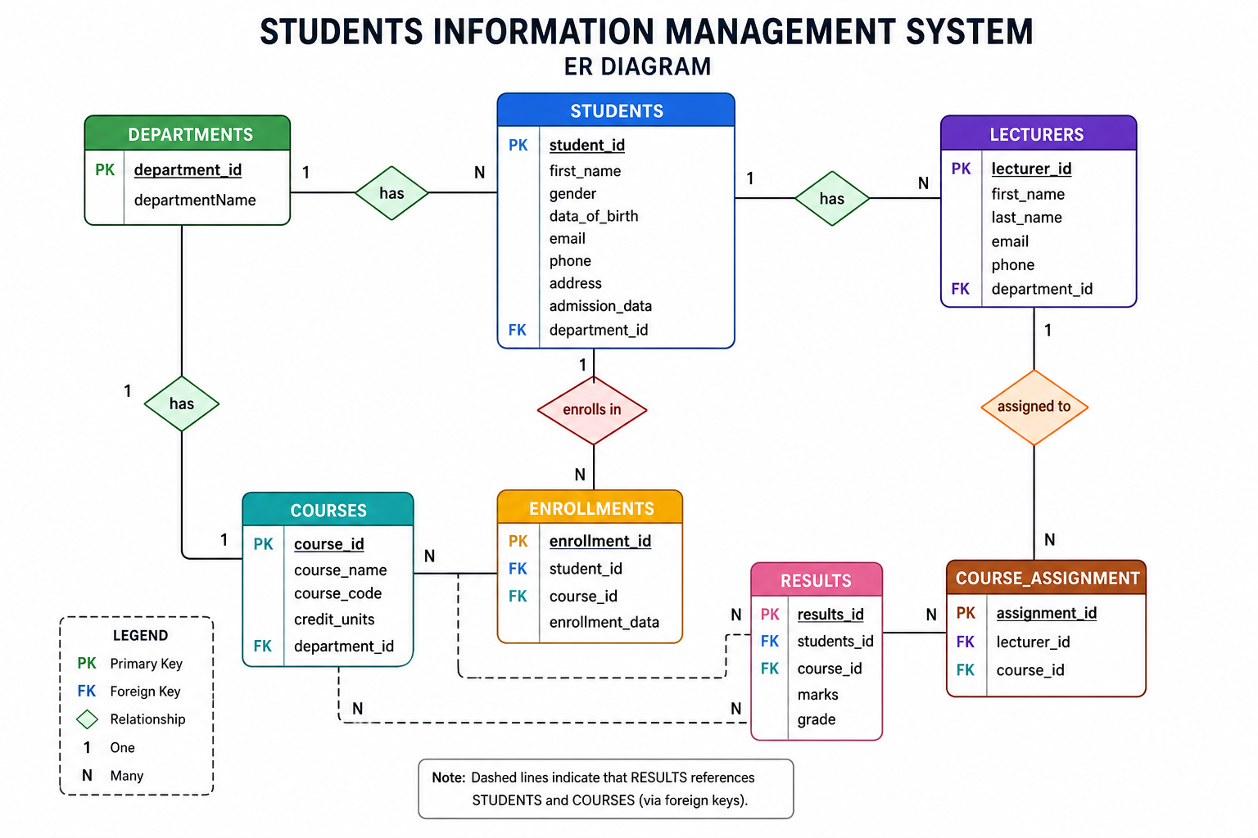

The Physical Design; The Database Schema:

Table Name | Attributes | Primary key | Foreign key
Department: | department Name, department_id. | Department_id | Location_id
Students: | student_id, first_name, gender, data_of_birth, email, phone, address, admission_data, department_id. | Student_id | Department_id
Lecturers: | lecturer_id, first_name, last_name, email, phone, department_id. | Lecturer_id | Department_id
Courses | course_id, course_name, course_code, credit_units, department_id. | Course_id | Department_id
Enrollments | enrollment_id, student_id, course_id, enrollment_data. | Enrollment_id | Student_id, course_id
Results | results_id, students_id, course_id, marks, grade. | Results_id | Student_id, course_id
Course_Assignment: | assignment_id, lecturer_id, course_id. | Assignment_id | Lecturer_id, course_id

- User Interface:

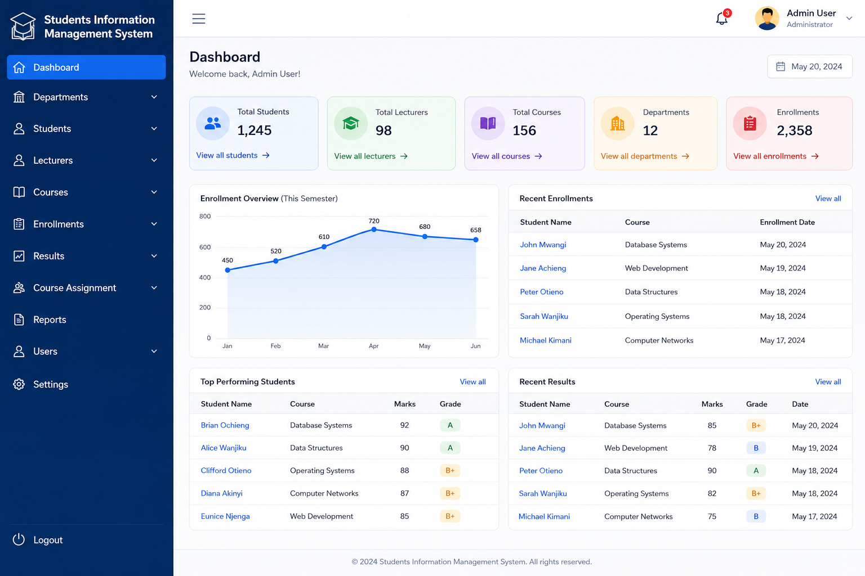
PHYSICAL DESIGN.

The following SQL code is the physical implementation of the community policing feedback system which creates tables for the entities above.
SHOW DATABASES
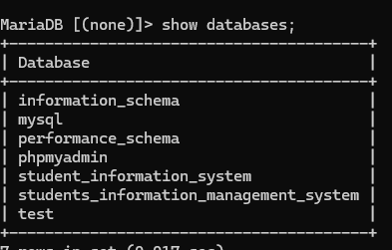

SHOWING TABLES FOR THE PROJECT TITLE SIMS
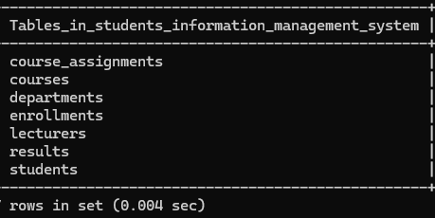

DEPARTMENT TABLE.
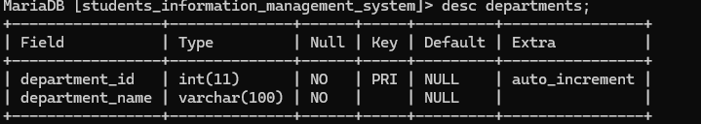

STUDENT TABLE
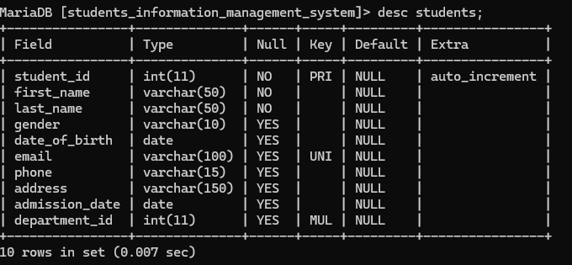
COURSE TABLE

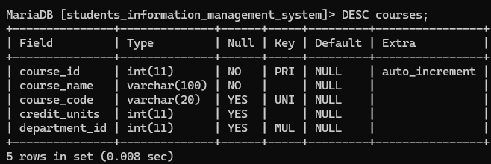
LECTURER TABLE.
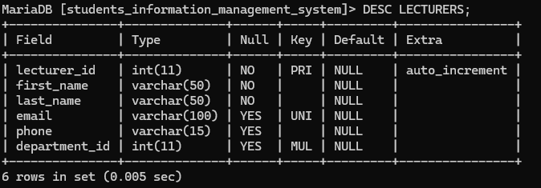
ENROLLMENT TABLE.

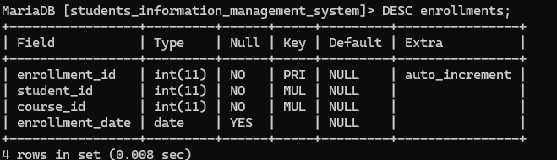
RESULTS TABLE.
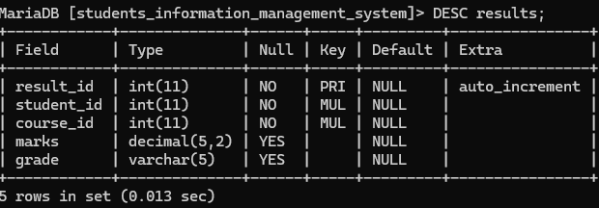

COURSE_ASSIGNMENTS.
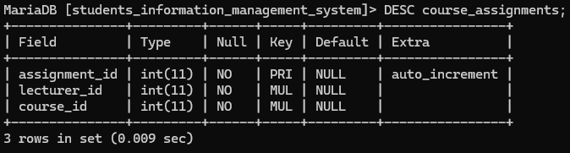

- Conclusion.
In conclusion, the Students Information Management System provides a reliable, scalable, and efficient solution for managing academic information. Its implementation using MySQL ensures strong performance, data integrity, and flexibility, making it suitable for modern educational institutions seeking to improve their administrative processes.

- Bibliography
- • Connolly, T., & Begg, C. (2015). Database Systems: A Practical Approach to Design, Implementation, and Management (6th ed.). Pearson Education Limited.
- • MySQL Documentation
- • W3Schools SQL Tutorial
- • Eclipse IDE for Java Developers
- • Elmasri, R., & Navathe, S. B. (2016). Fundamentals of Database Systems (7th ed.). Pearson.
- • Lucidchart ER Diagram Tutorial

